Polynomials and Their Roots

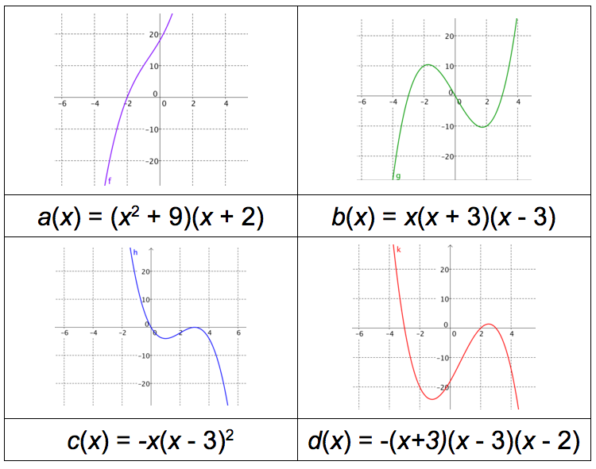

_{Task from New Visions Math}
CR - A2 - U4 - B3 - Factored and Unfactored Forms

