HS Transformations

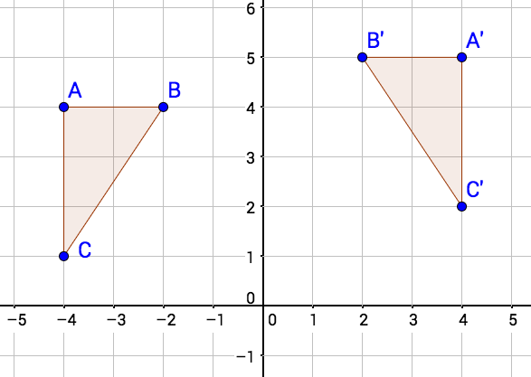 | 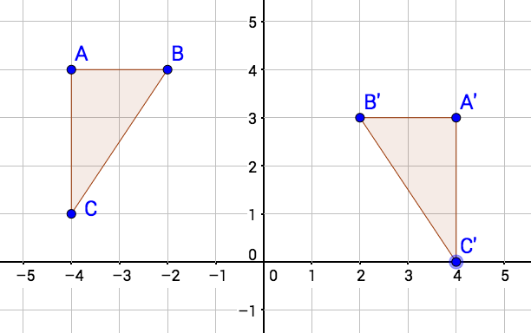
Reflect about the y-axis  then translate +1 vertically. | Reflect about the y-axis  then translate -1 vertically.
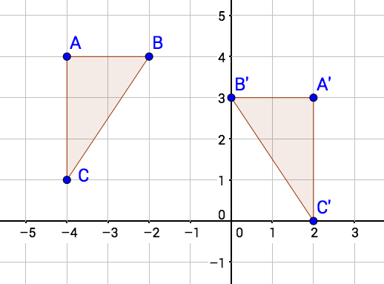 | 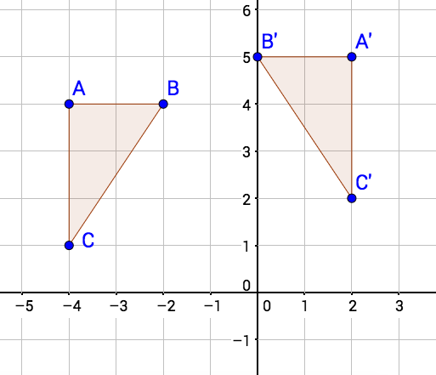
Reflect about the line x = -1  then translate -1 vertically. | Reflect about the line x = -1  then translate +1 vertically.

_{From}
_{New Visions Math}
CR - G - U1 - B4 - Reflections, Translations, Graphs, Sentences

